Our guests from America:
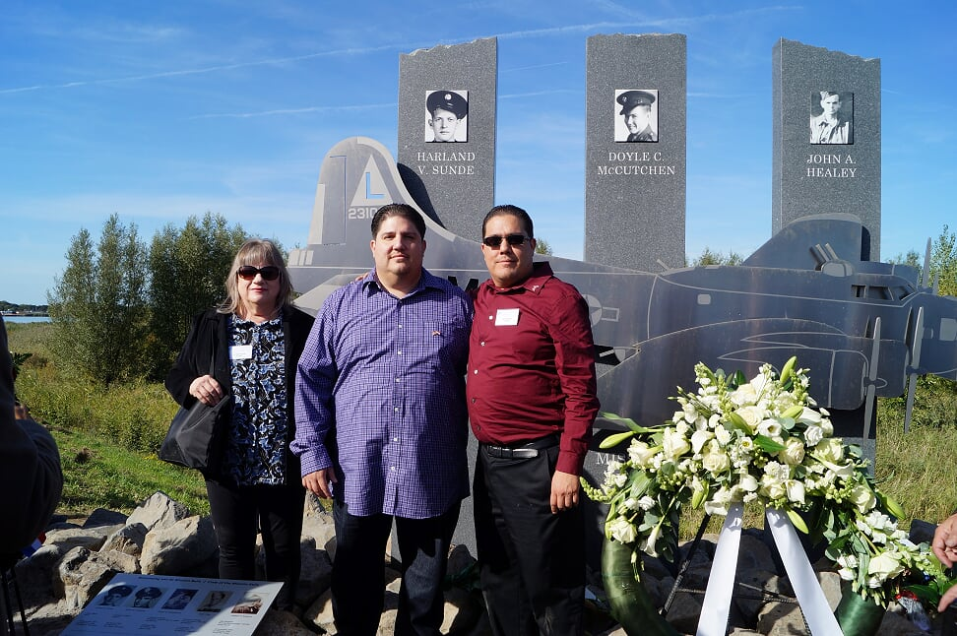
Ero Aguirre, Roman Aguirre and Gabriel Aguirre
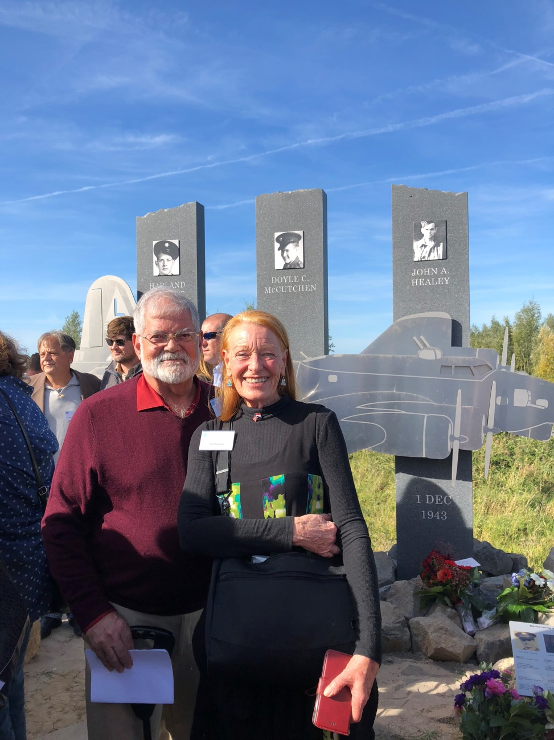
Jim Sweaney and Kaye Sweaney
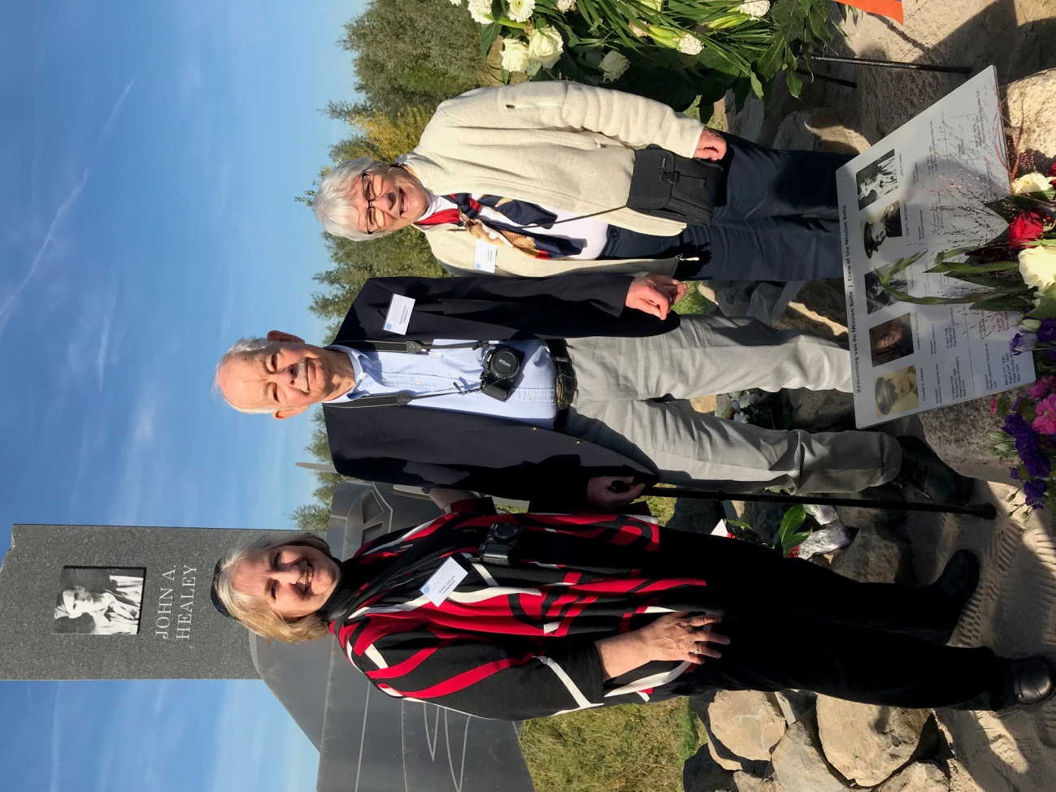
Kristen Johnson, Richard Johnson and Elizabeth Johnson
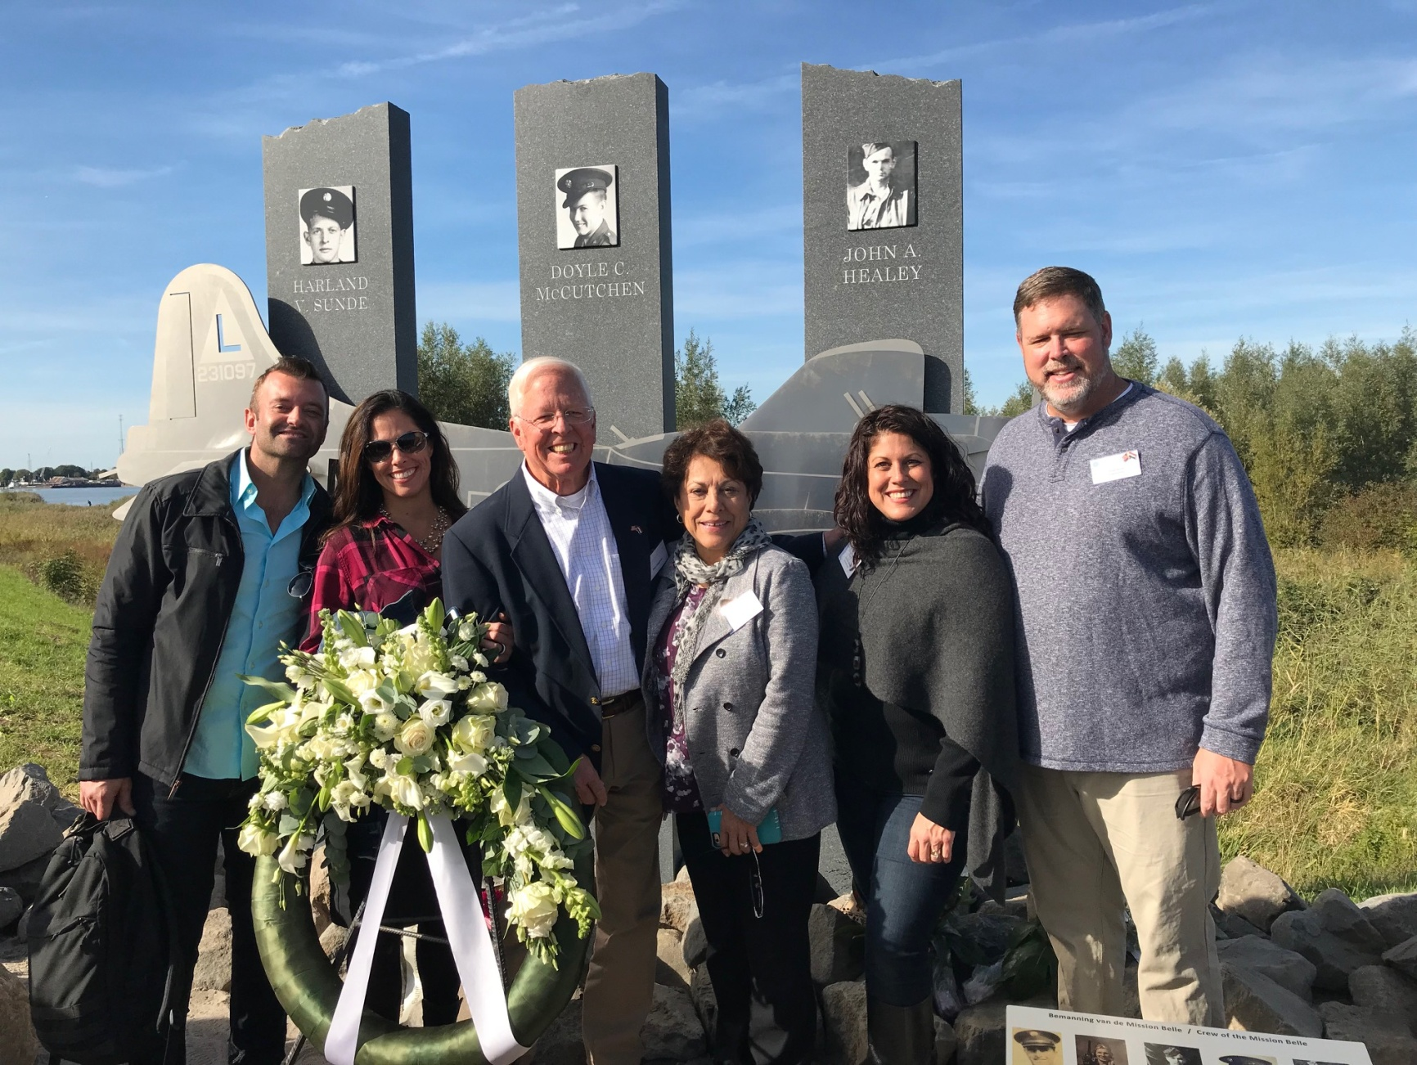
Brian Runnels, Christine Runnels Josephson, Paul Josephson, Cynthia Josephson, Jennifer Brush Josephson and Brad Brush
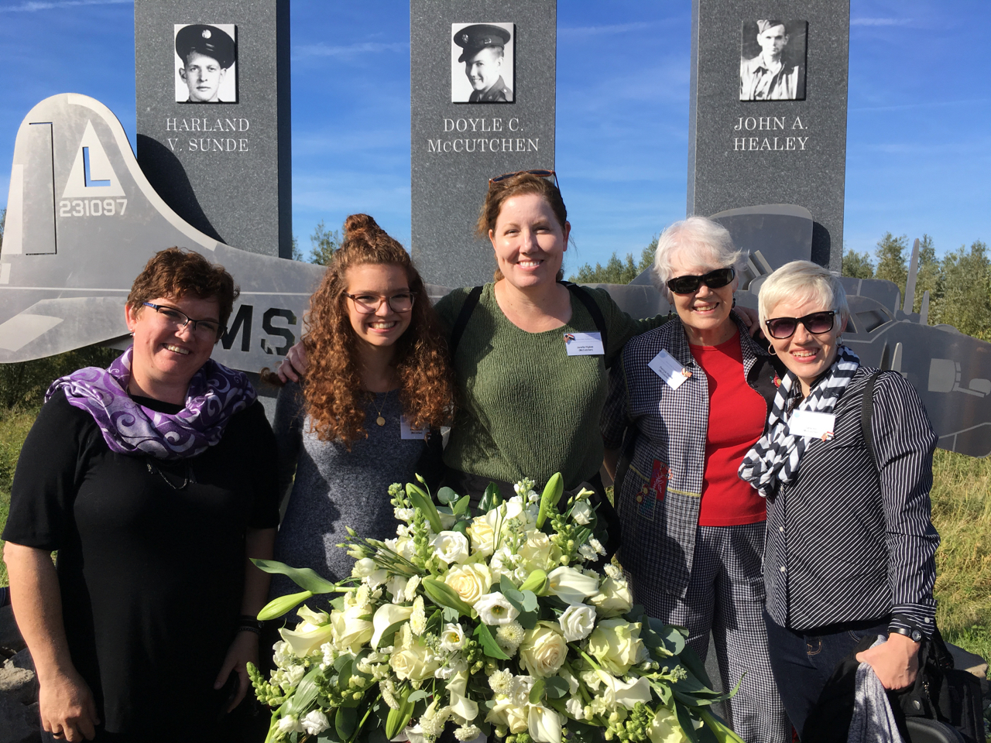
Dawn Roberts, Adelia Roberts, Janelle Higbee, Patricia Higbee and Lana Hill
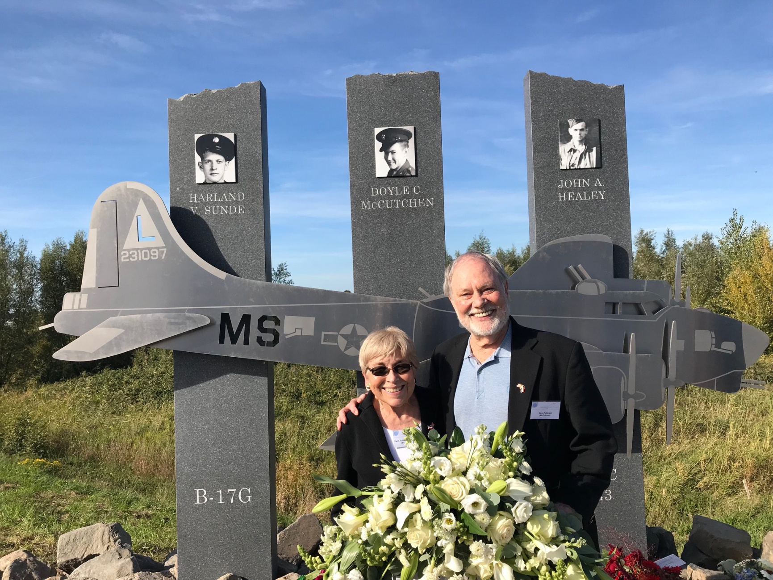
Carol Jo Pottenger and Ken Pottenger
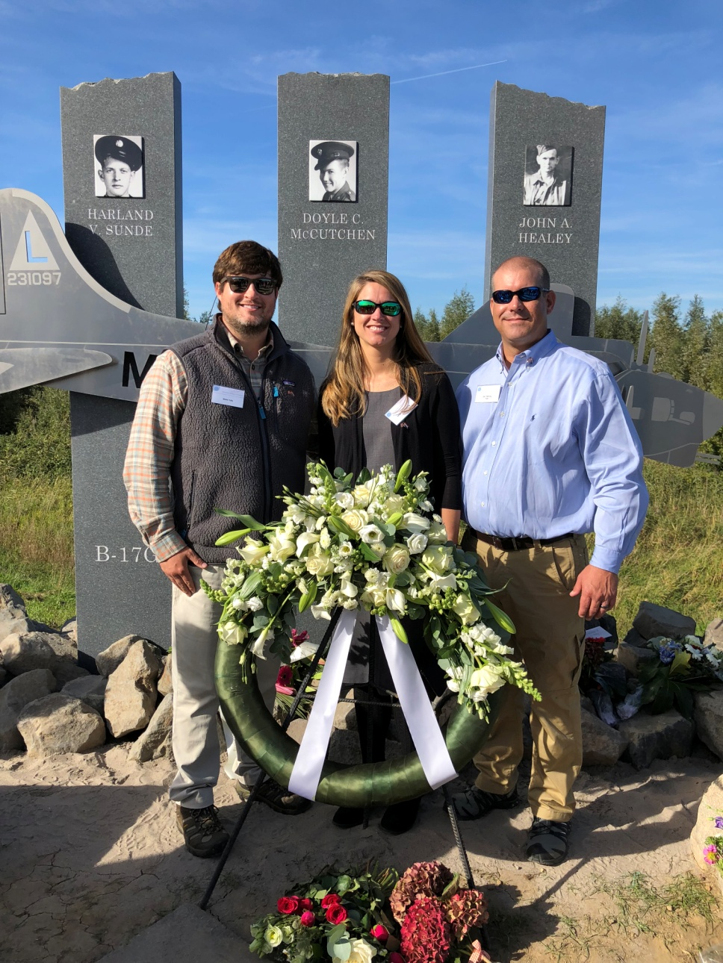
Blake Tully, Leigh Ann Fleming (Tully) and Zac Fleming
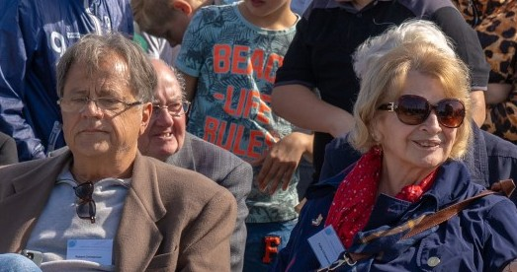
Bob Christensen and Kathy Christensen
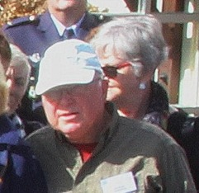
Bob Berger and Charlene Berger
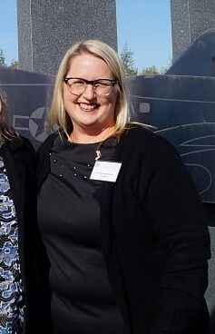
Jana Churchwell Scott
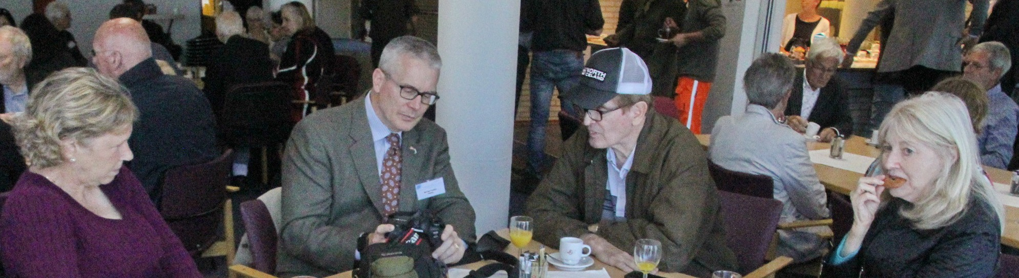
Pat Philbin, Mike Philbin, Brian Philbin and Caroline Scheer
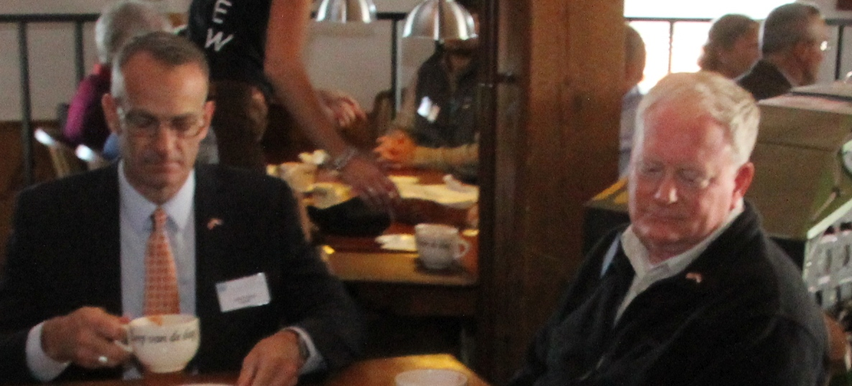
John Hanlon and Douglas Hanlon (photo Mikenzie Hanlon missing)

